**LAUNCH OF WOMEN POWER INTERNATIONAL**

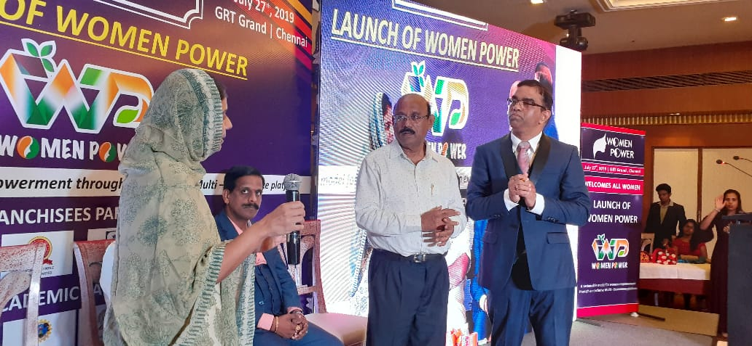 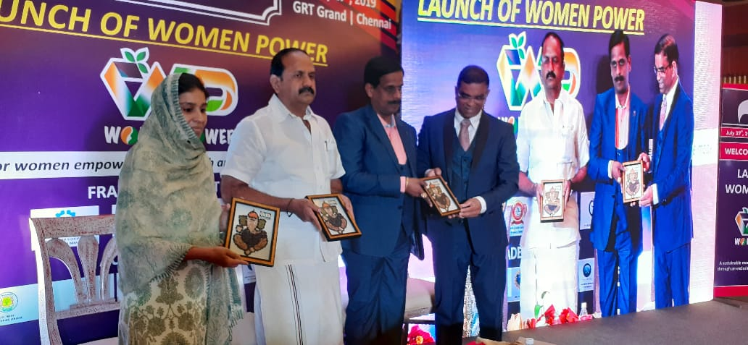

**Venue : GRT Grand Hotel ,T.Nagar,Chennai**

**Dept : Crescent Innovation & Incubation Council**

**Date : July 27th,2019**